**Zaoberal som sa databázou futbalovej ligy**

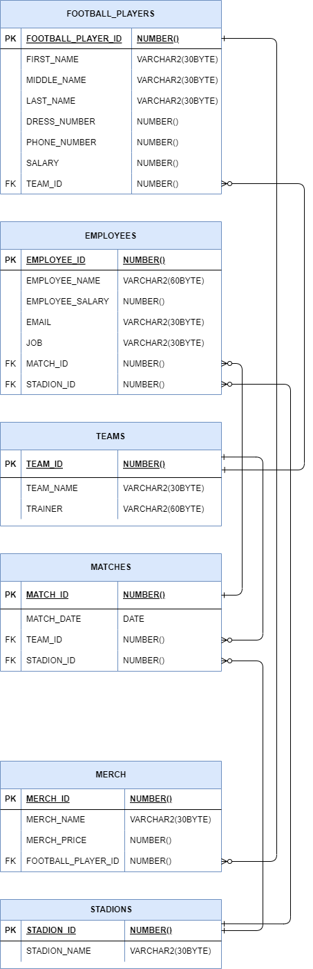

**Úloha1: 2 pohľady s netriviálnym selektom**

**1.zobrazí najmenší plat zamestnanca**

CREATE VIEW view_1 AS   
 SELECT MIN(salary) AS min_salary FROM FOOTBALL_PLAYERS;

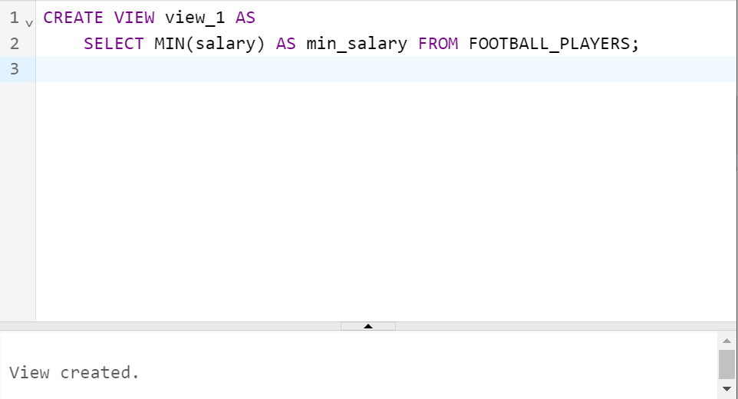

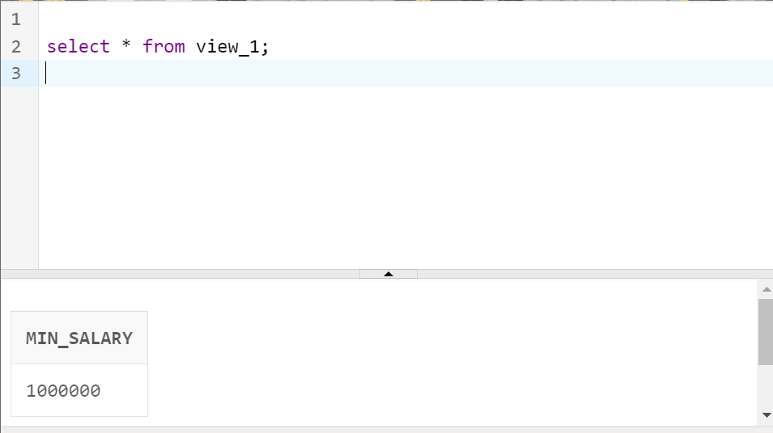

**2.zobrazí priemerný plat zamestnancov**

* CREATE VIEW view_2 AS   
   SELECT AVG(salary) AS avg_salary FROM FOOTBALL_PLAYERS;

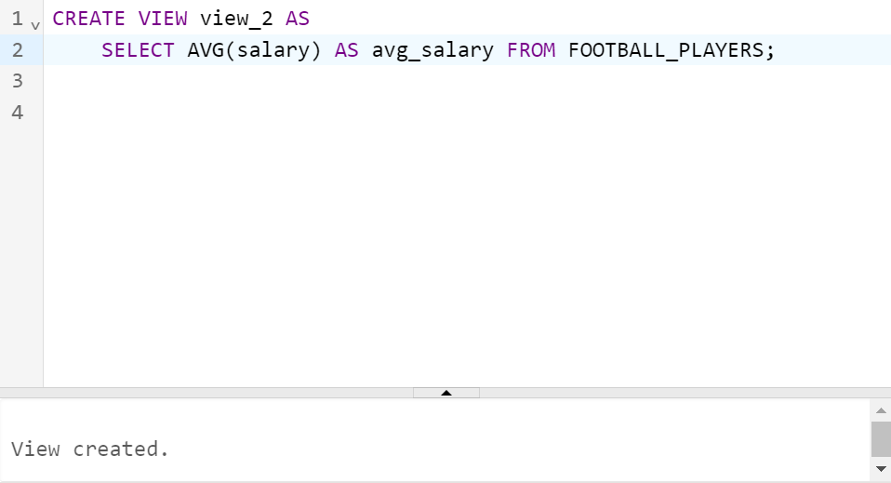

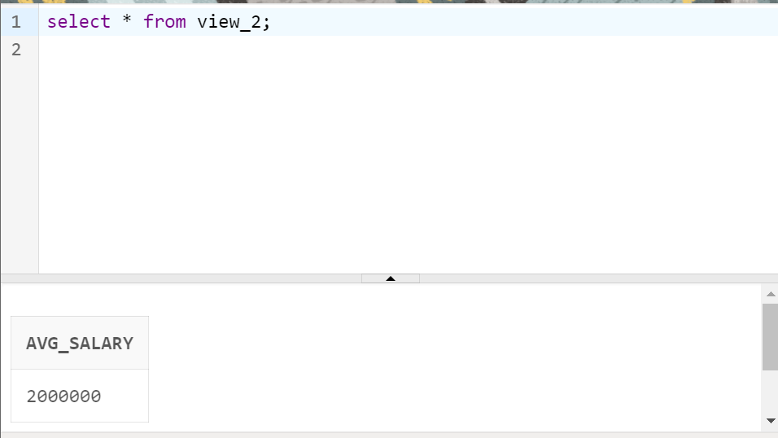

**Úloha2: 3 pohľady so spájaním tabuliek**

**1.outer join**

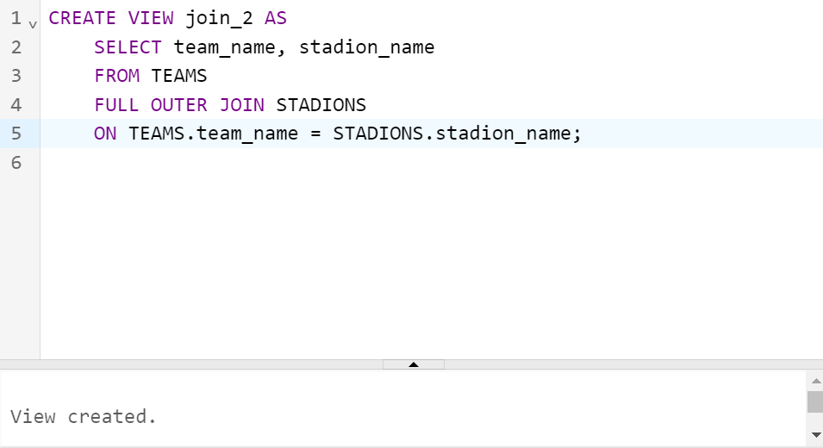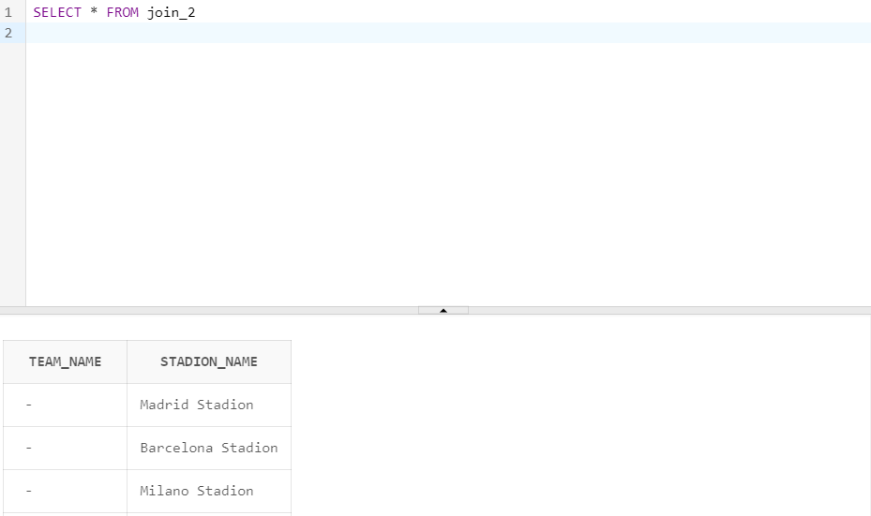

**2.spojenie aspoň 2 tab.**

* CREATE VIEW join_3 AS   
   SELECT * FROM FOOTBALL_PLAYERS   
   NATURAL JOIN TEAMS;

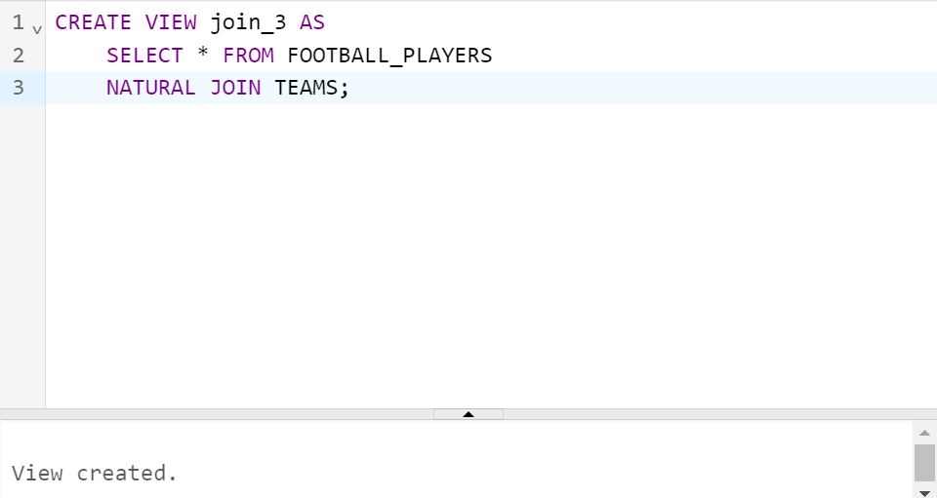

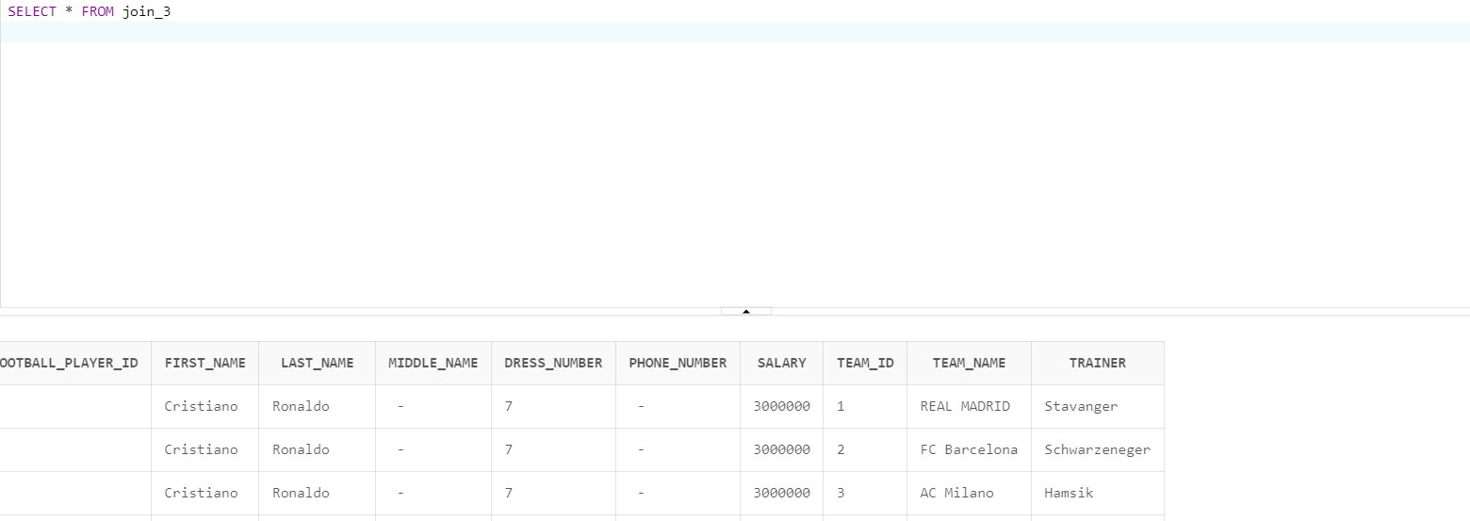

**3.spojenie troch tabuliek**

* CREATE VIEW join_1 AS   
   SELECT * FROM FOOTBALL_PLAYERS   
   NATURAL JOIN TEAMS   
   NATURAL JOIN EMPLOYEES;

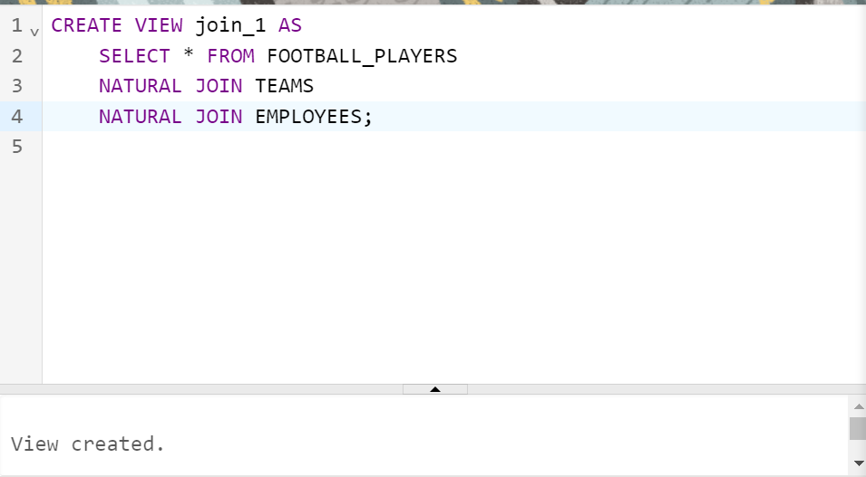

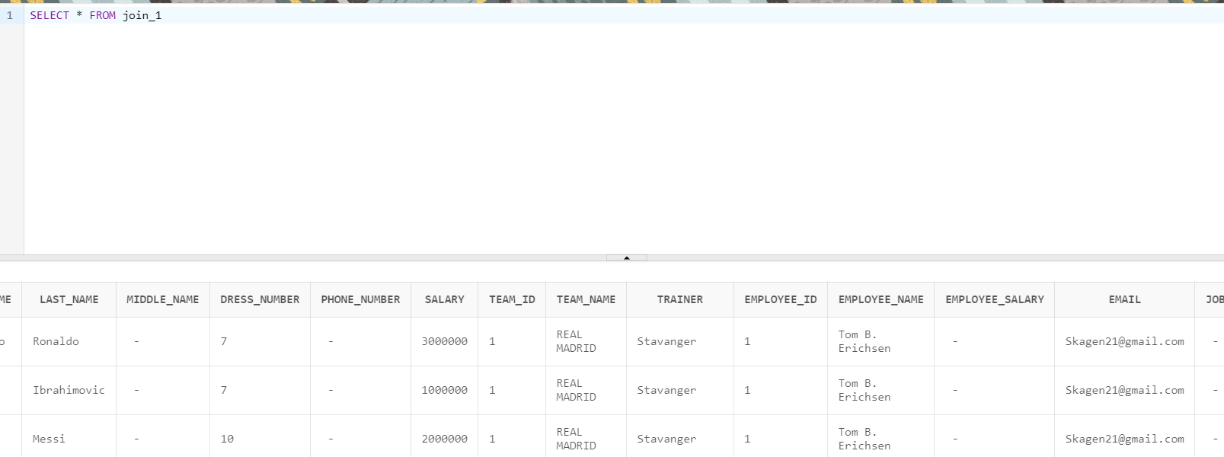

**Úloha 3: 2 pohľady s použitím agregačných funkcii / zoskupenia**

1. **funkcia zobrazujúca počet vyplnených emailov**

CREATE VIEW agr_function AS   
 SELECT COUNT(email) AS emails_count   
 FROM EMPLOYEES   
 WHERE email != NULL;

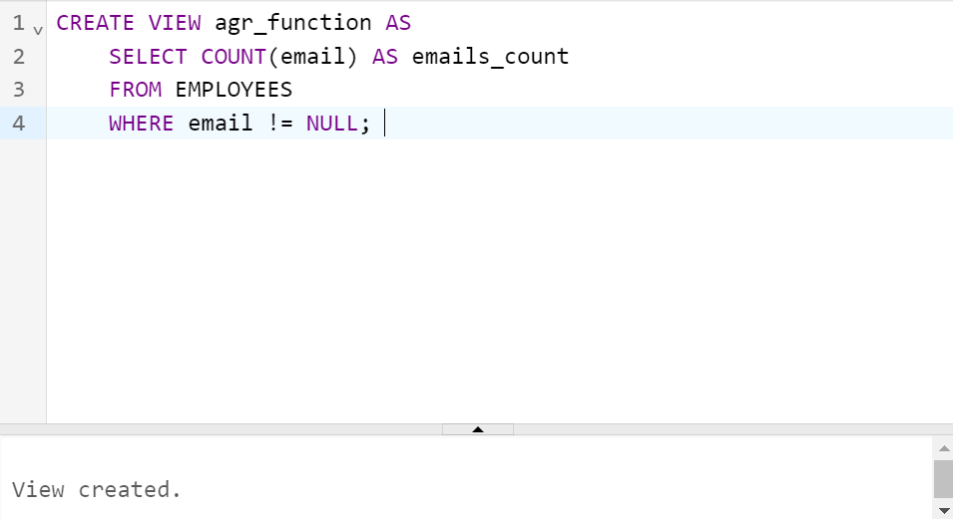

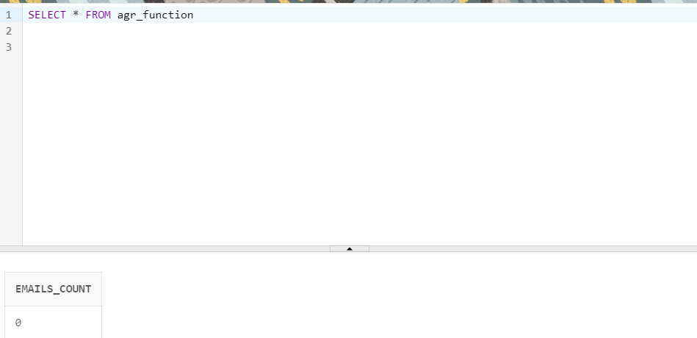

1. **merch, ktorého cena je menej ako 10**

CREATE VIEW list(merch_id, merch_price) AS   
 SELECT MAX(merch_id), merch_price FROM MERCH   
 GROUP BY merch_price   
 HAVING MAX(merch_price) < 10;

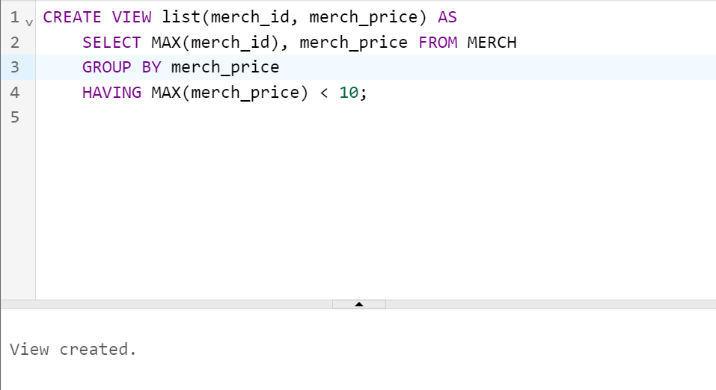

* CREATE TABLE Football_players (   
  Football_player_ID int,   
  First_name varchar(255),   
  Last_name varchar(255),   
  Middle_name varchar(255),   
  Dress_number int,   
  Phone_number int,   
  Salary int,   
  PRIMARY KEY (Football_player_ID)   
  );
* CREATE TABLE Teams(   
  Team_id int,   
  Team_name varchar(255),   
  Trainer varchar(255),   
  PRIMARY KEY (Team_id)   
  );
* CREATE TABLE Matches(   
  Match_id int,   
  Match_date Date,   
  PRIMARY KEY (Match_id)   
  );
* CREATE TABLE Merch(   
  Merch_id int,   
  Merch_name varchar(255),   
  Merch_price int,   
  PRIMARY KEY (Merch_id)   
  );
* CREATE TABLE Employees(   
  Employee_id int,   
  Employee_name varchar(255),   
  Employee_salary int,   
  Email varchar(255),   
  Job varchar(255),   
  PRIMARY KEY (Employee_id)   
  );
* CREATE TABLE Stadions(   
  Stadion_id int,   
  Stadion_name varchar(255),   
  PRIMARY KEY (Stadion_id)   
  );
* CREATE VIEW view_1 AS   
   SELECT MIN(salary) AS min_salary FROM FOOTBALL_PLAYERS;
* CREATE VIEW view_2 AS   
   SELECT AVG(salary) AS avg_salary FROM FOOTBALL_PLAYERS;
* CREATE VIEW join_1 AS   
   SELECT * FROM FOOTBALL_PLAYERS   
   NATURAL JOIN TEAMS   
   NATURAL JOIN EMPLOYEES;
* CREATE VIEW join_3 AS   
   SELECT * FROM FOOTBALL_PLAYERS   
   NATURAL JOIN TEAMS;
* CREATE VIEW agr_function AS   
   SELECT COUNT(email) AS emails_count   
   FROM EMPLOYEES   
   WHERE email != NULL;
* CREATE VIEW list(merch_id, merch_price) AS   
   SELECT MAX(merch_id), merch_price FROM MERCH   
   GROUP BY merch_price   
   HAVING MAX(merch_price) < 10;
* INSERT INTO FOOTBALL_PLAYERS (football_player_id, first_name, last_name, dress_number, salary)   
   VALUES ('1', 'Zlatan', 'Ibrahimovic', '7', '1000000');
* INSERT INTO FOOTBALL_PLAYERS (football_player_id, first_name, last_name, dress_number, salary)   
   VALUES ('2', 'Lionel', 'Messi', '10', '2000000');
* INSERT INTO FOOTBALL_PLAYERS (football_player_id, first_name, last_name, dress_number, salary)   
   VALUES ('3', 'Cristiano', 'Ronaldo', '7', '3000000');
* INSERT INTO TEAMS (team_id, team_name, trainer)   
   VALUES ('1', 'REAL MADRID', 'Stavanger');
* INSERT INTO TEAMS (team_id, team_name, trainer)   
   VALUES ('2', 'FC Barcelona', 'Schwarzeneger');
* INSERT INTO TEAMS (team_id, team_name, trainer)   
   VALUES ('3', 'AC Milano', 'Hamsik');
* INSERT INTO Stadions (stadion_id, stadion_name)   
  VALUES ('1', 'Barcelona Stadion');
* INSERT INTO Stadions (stadion_id, stadion_name)   
  VALUES ('2', 'Madrid Stadion');
* INSERT INTO Stadions (stadion_id, stadion_name)   
  VALUES ('3', 'Milano Stadion');
* INSERT INTO EMPLOYEES (employee_id, employee_name, email)   
  VALUES ('2', 'Tom Cerichsen');
* INSERT INTO EMPLOYEES (employee_id, employee_name, email)   
  VALUES ('1', 'Tom B. Erichsen', '[Skagen21@gmail.com](mailto:Skagen21@gmail.com)');
* INSERT INTO EMPLOYEES (employee_id, employee_name, email)   
  VALUES ('2', 'Tom Cerichsen', NULL);
* INSERT INTO EMPLOYEES (employee_id, employee_name, email)   
  VALUES ('3', 'Rom Sen', '[romko@gmail.com](mailto:romko@gmail.com)');